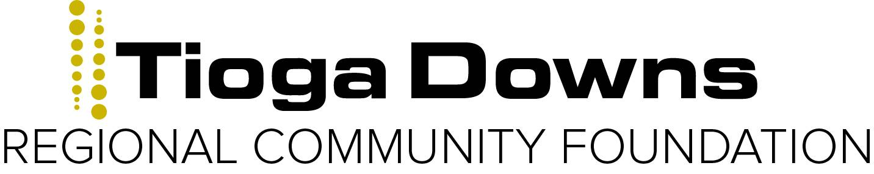

Grant Application Form

Instructions

- Please type and single-space all proposals.

- Please answer all of the questions in the order listed.

- Please use headings as provided.

- Please submit

  - Electronically to TiogaFoundation@TiogaDowns.com.
  - One paper copy to PO Box 15, Nichols NY 13812

- Please do not include any materials other than those specifically requested at this time.

Cover Sheet

Date of application: Click here to enter text.

Name of organization to which grant would be paid. Please list exact legal name:
Click here to enter text.

Purpose of grant (one sentence): Click here to enter text.

Address of organization: Click here to enter text.

Telephone number: Click here to enter text.Fax: Click here to enter text.E-mail: Click here to enter text.

Executive director: Click here to enter text.

Contact person and title (if not executive director): Click here to enter text.

Is your organization an IRS 501(c) (3) not-for-profit?: Yes ☐ or No ☐

If no, please explain: Click here to enter text.

Grant request: $ Click here to enter text.

Check one (based on the organization’s priorities and the funder’s guidelines):

General support ☐

Project support ☐

Total organizational budget (for current year): $Click here to enter text.

Dates covered by this budget (mo/day/year): Click here to enter text.

Total project budget (if requesting project support):$Click here to enter text.

Dates covered by project budget (mo/day/year): Click here to enter text.

Project name (if applicable): Click here to enter text.

Grant Proposal Format

Please write your proposal using the following format, answering all of the questions in the order listed and using headings as provided.

This document is NOT intended to be a form to complete but rather a format to follow. Please prepare your proposal as a separate document.

Proposal Format

I. PROPOSAL SUMMARY: one-half page, maximum
Please summarize in a short paragraph the purpose of your agency. Briefly explain why your agency is requesting this grant, what outcomes you hope to achieve, and how you will spend the funds if a grant is made.

II. NARRATIVE—Two pages maximum.

A. Background— Two pages maximum
Describe the work of your agency, addressing each of the following:

- A brief description of its history and mission.
- The need or problem that your organization works to address, and the population that your agency serves, including geographic location, socioeconomic status, race, ethnicity, gender, sexual orientation, age, physical ability, and language.
- Current programs and accomplishments. Please emphasize the achievements of the recent past.
- Number of paid full-time staff; number of paid part-time staff; number of volunteers.
- Your organization’s relationships — both formal and informal — with other organizations working to meet the same needs or providing similar services.
Please explain how you differ from these other agencies.

B. Funding Request— Two pages maximum
Please describe the program for which you seek funding.

- If applying for general operating support, briefly describe how this grant would be used.
- If your request is for a specific project, please explain the project including:
  - A statement of its primary purpose and the need or problem that you are seeking to address
  - The population that you plan to serve and how this population will benefit from the project.
  - Strategies that you will employ to implement your project.
  - The proposed staffing pattern for the project, and the names and titles of the individuals who will direct the project.
  - Anticipated length of the project.
  - How the project contributes to your organization’s overall mission.

C. Evaluation— One page maximum
Please explain how you will measure the effectiveness of your activities. Describe your criteria for a successful program and the results you expect to have achieved by the end of the funding period.

III. ATTACHMENTS—Please label all attachments to correspond to the bold-faced, capitalized items below.

- Financial Information—Please provide the dates that each document covers.

- Your MOST RECENT FINANCIAL STATEMENT, audited if available. This statement should reflect actual expenditures and funds received during your most recent fiscal year.
- Aligned side by side on the same page, your OPERATING EXPENSE
BUDGETS for the current and most recent fiscal year.
- Aligned side by side on the same page, a list of foundation and corporate SUPPORTERS and all other sources of income, with amounts, for your current and most recent fiscal year.
- Please list the foundations, corporations, and other SOURCES that you are
SOLICITING FOR FUNDING and, to the best of your knowledge, the
STATUS OF YOUR PROPOSAL with each.
- If project funding is requested:
  - A CURRENT EXPENSE BUDGET FOR THE PROJECT. List each staff line separately and include % of time spent on project. Indicate the specific uses of the requested grant, if possible.
  - A list of all SOURCES OF INCOME toward the project, actual and prospective with amounts.

- Other Supporting Materials

- A list of your Board of Directors, with their affiliations.
- A copy of your most recent IRS letter indicating your agency’s tax exempt status, or, if not available, an explanation.
- One-paragraph resumes of key staff, including qualifications relevant to the specific request.
- Your most recent annual report, if available.
- No more than three examples of recent articles about, or evaluations of, your organization, if available.

